**Ejercicios primera tanda de exposiciones**

**Tubo de rayos catódicos:**

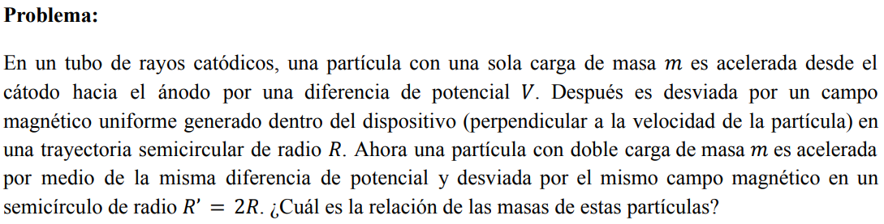

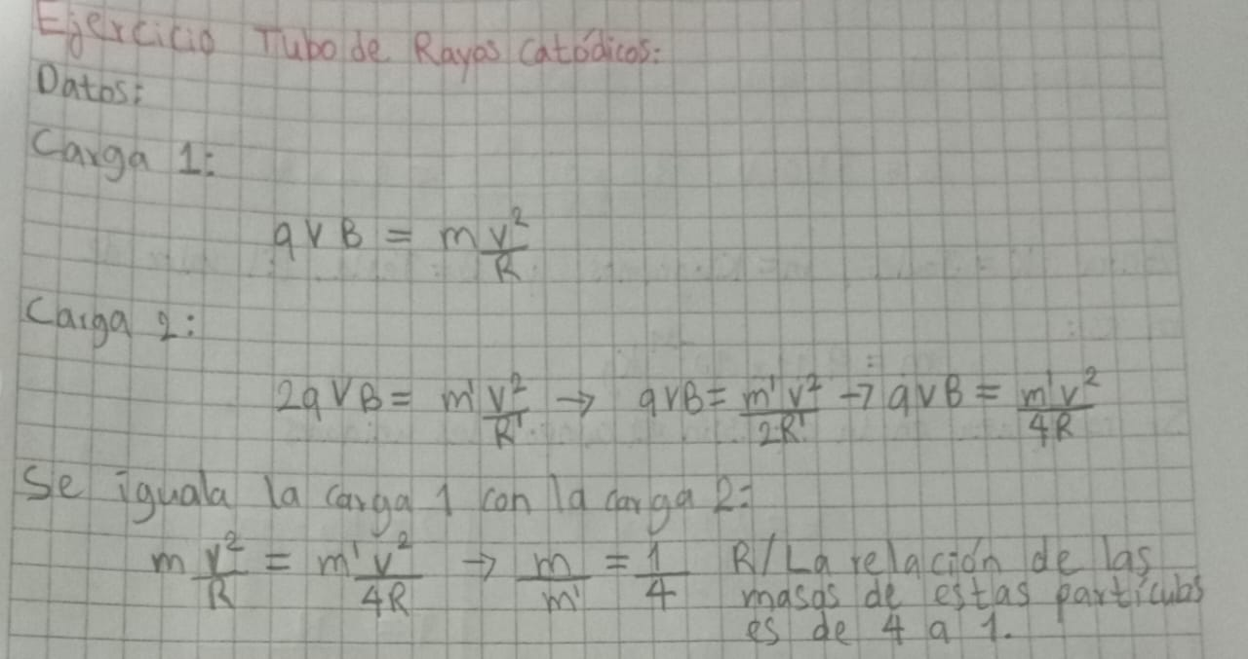**Selector de velocidad:**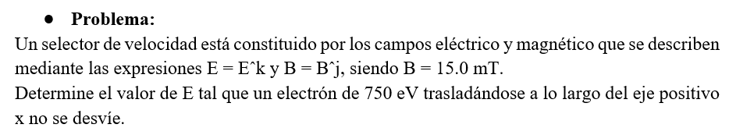

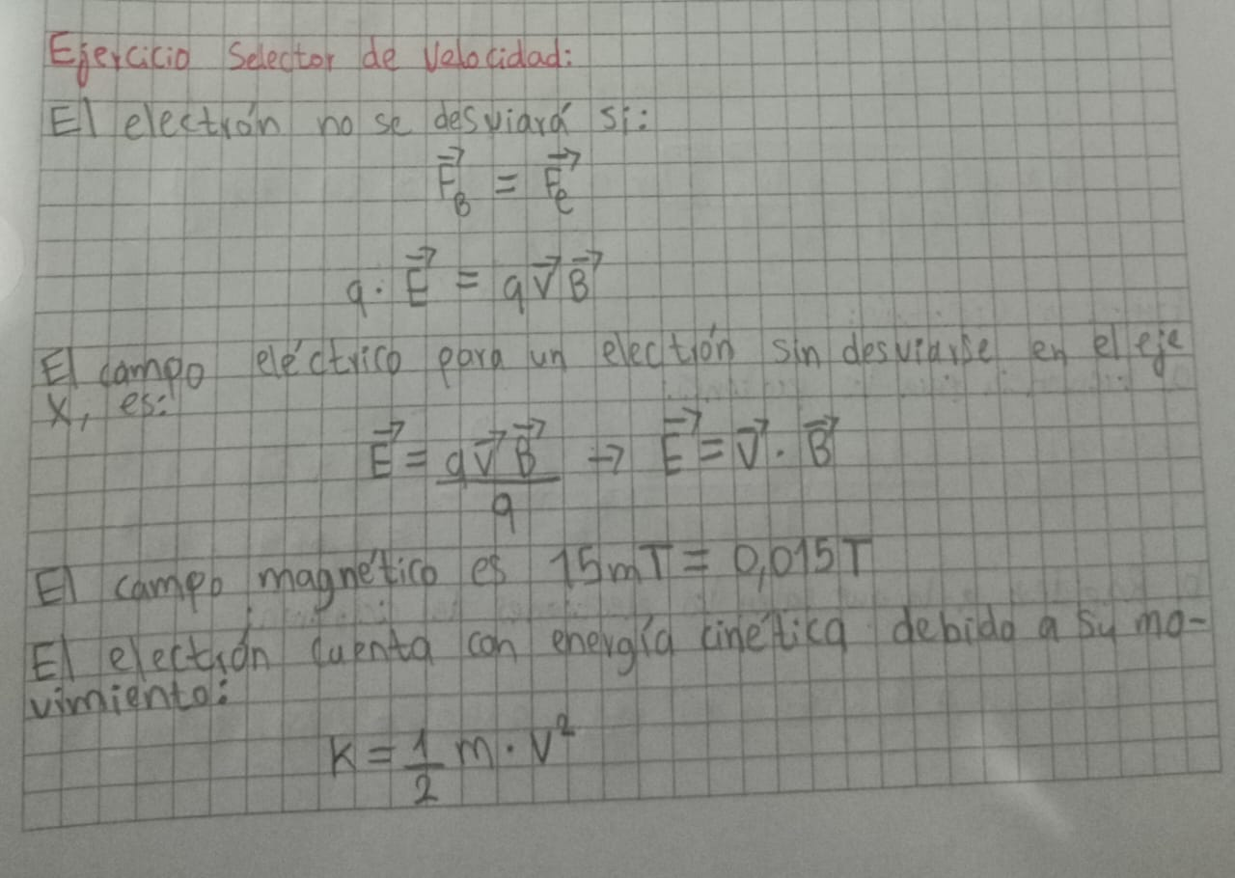

**Ciclotrón:**

**Problema:**

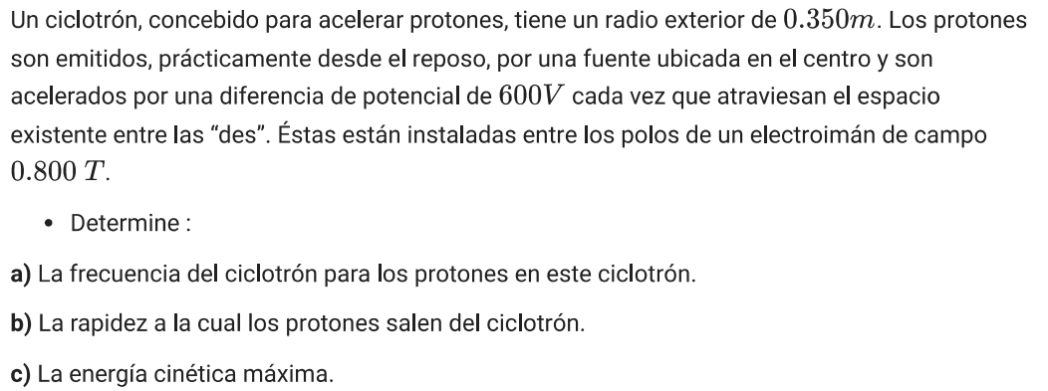

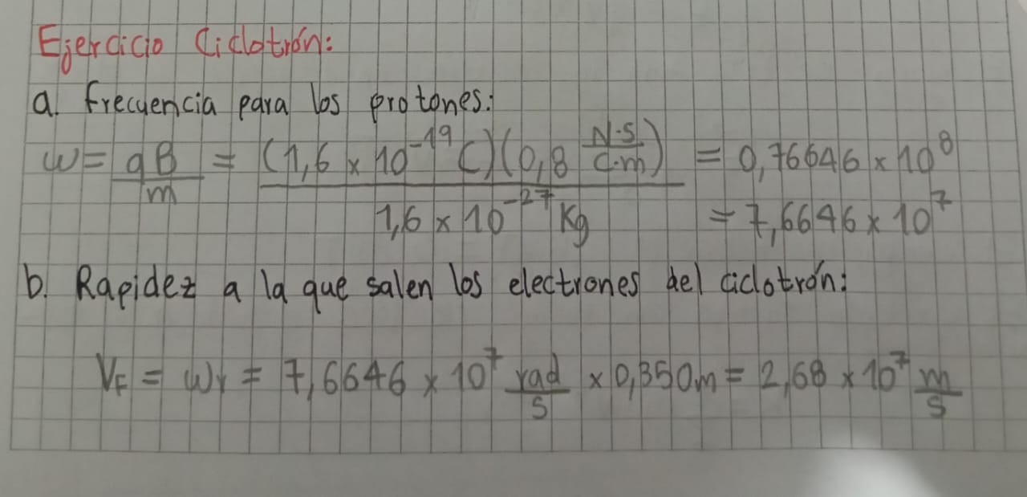

**Sincrociclotrón:**

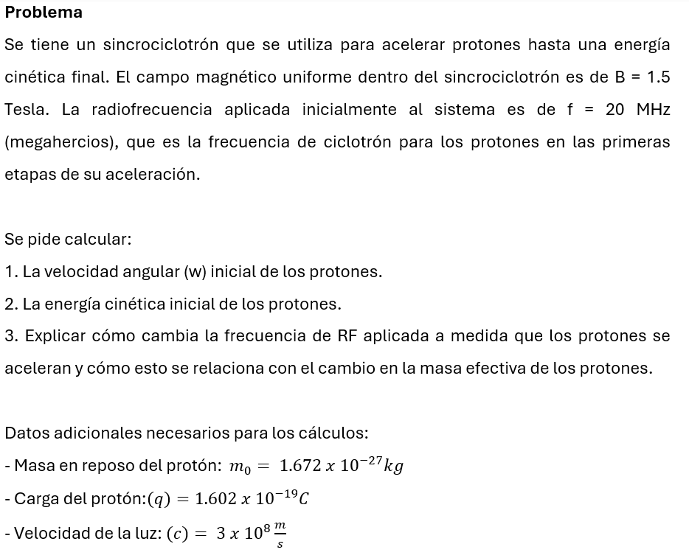

**Campo magnético terrestre:**

**Problema:**

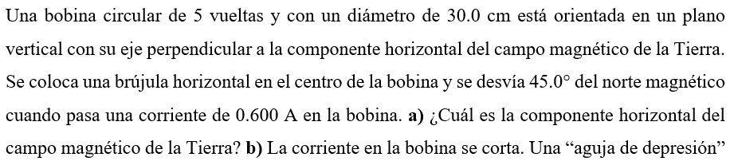

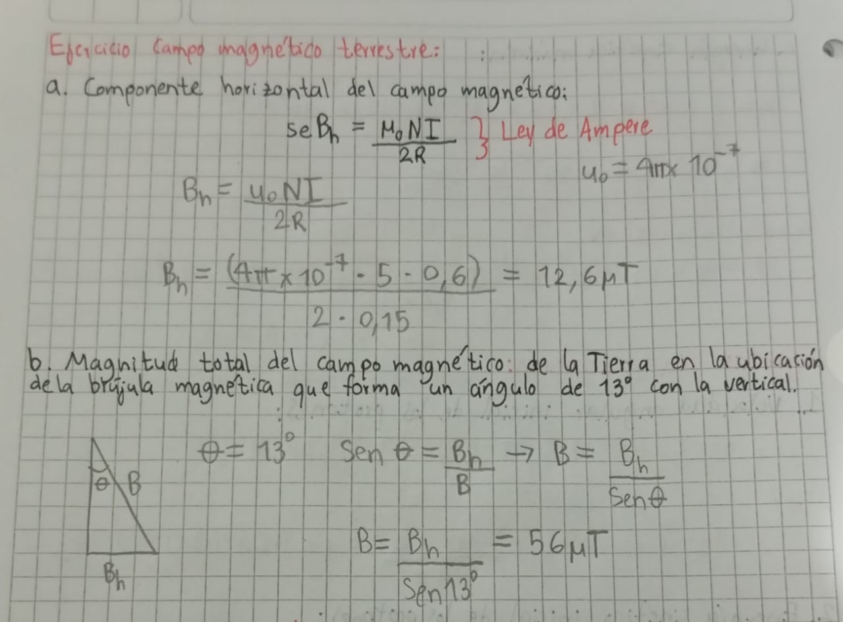

**Campo magnético del Sol:**

**Problema:**

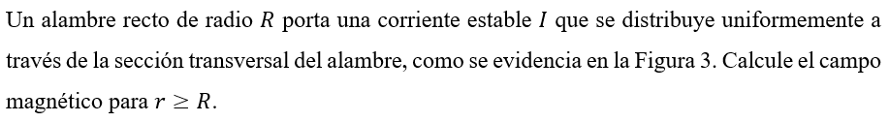

**Campos Van Allen:**

**Problema:**

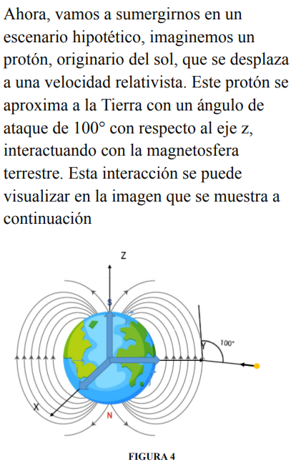

**Botellas magnéticas:**

**Espectrómetro de masas:**